**UNIT #12**

**MAIN FLOOR**

Finished Area: 1,407 sq. ft.

**BASEMENT FLOOR**

Finished Area: 1,242 sq. ft.

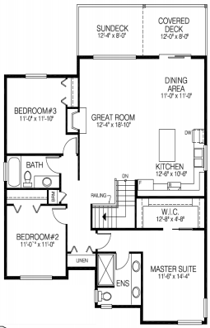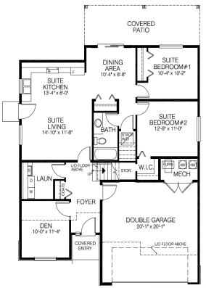

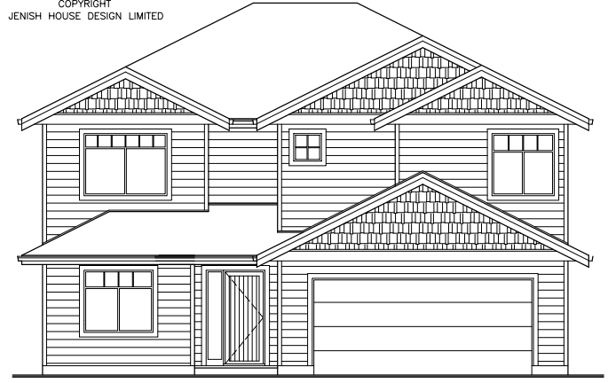



Actual home may vary from rendering/floor plan.

Any measurements provided are approximate only.