UNIT #3/4
Total Finished Area: 2900 sq. ft./side

SECOND FLOOR
Finished Area: 1032 sq. ft./side

MAIN FLOOR
Finished Area: 967 sq. ft./side

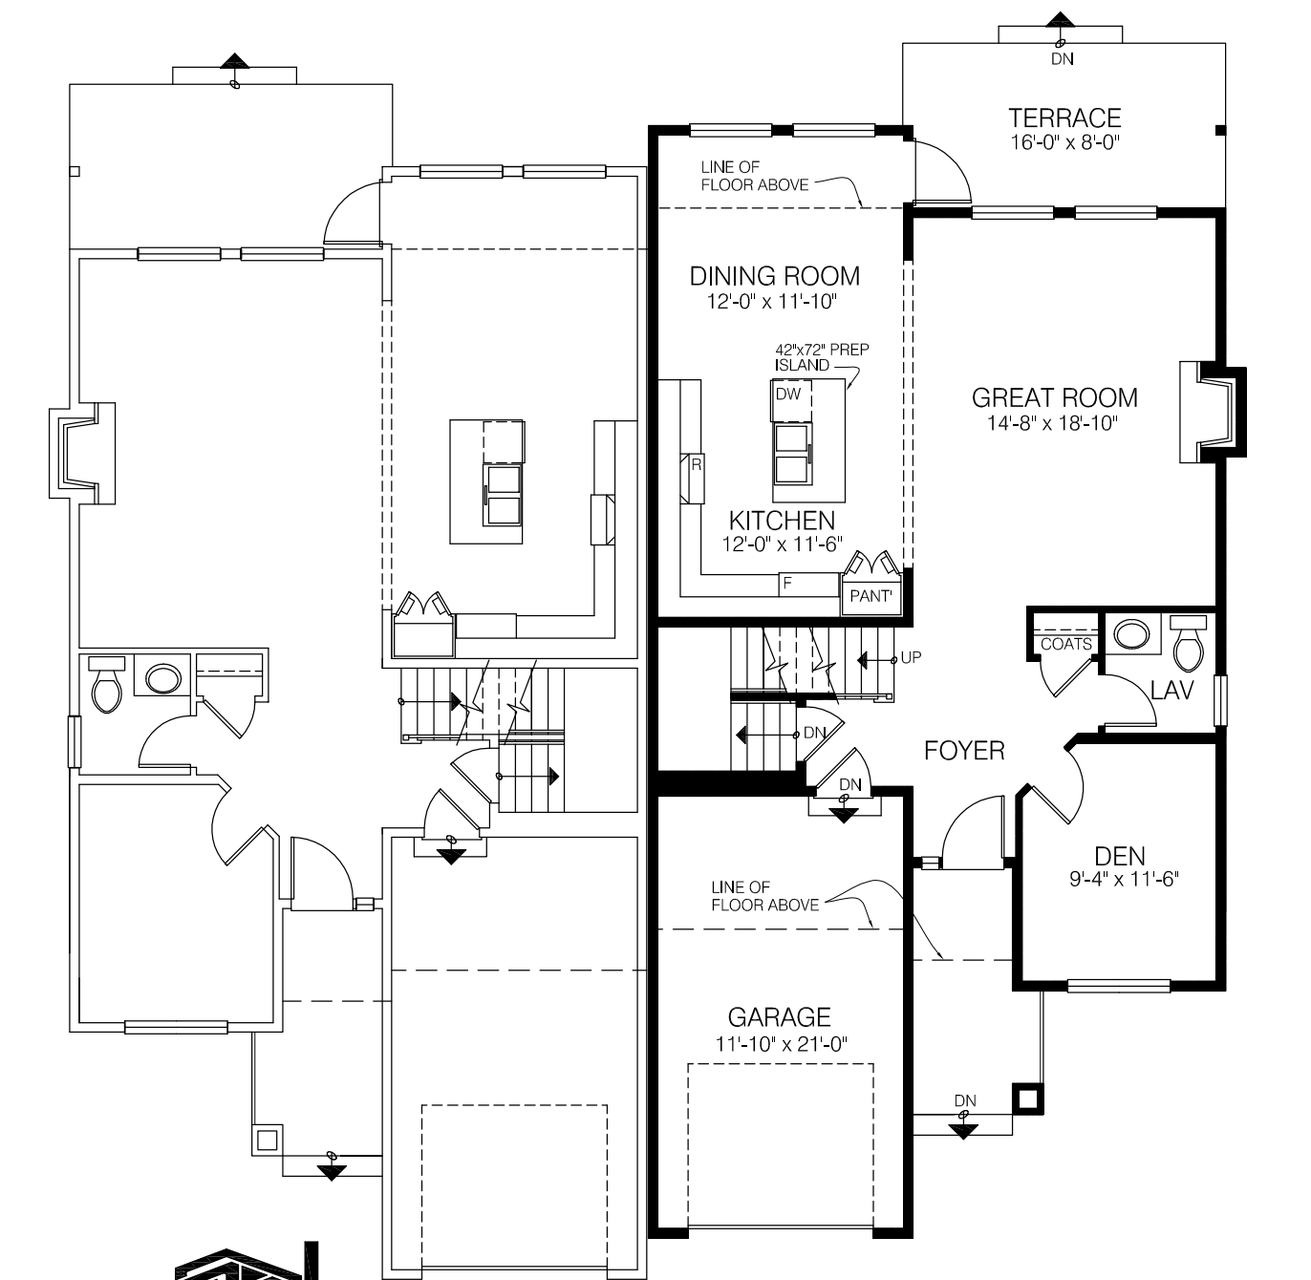

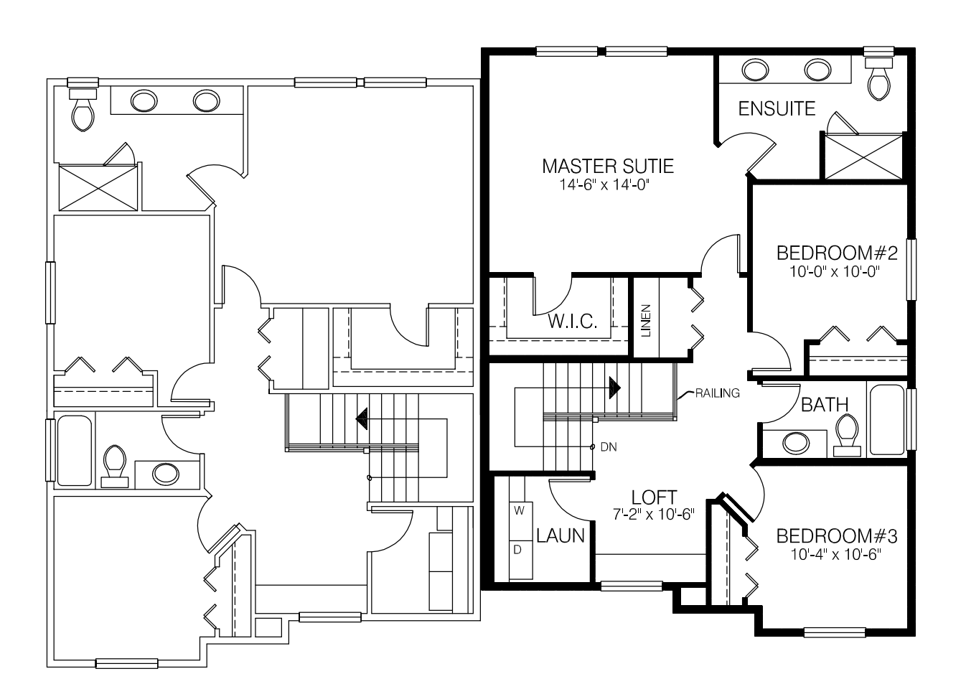

THIS DESIGN INCLUDES A FINISHED BASEMENT

Actual home may vary from rendering/floor plans.
Any measurements provided are approximate only.

UNIT #3/4
Total Finished Area: 2900 sq. ft./side

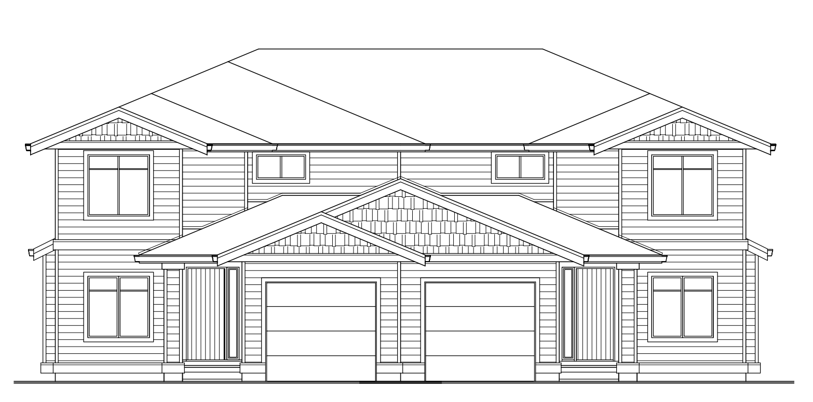
THIS DESIGN INCLUDES A FINISHED BASEMENT

Finished Basement (901 Sq. Ft.) Includes:

Private exterior entrance Large Recreation Room
Bedroom Bathroom
Wet Bar Storage Room

Actual home may vary from rendering/floor plans.
Any measurements provided are approximate only.

